The Fleetrock Alvys Business Central integration has the following workflow:
A Repair Order is created and populated in Fleetrock:
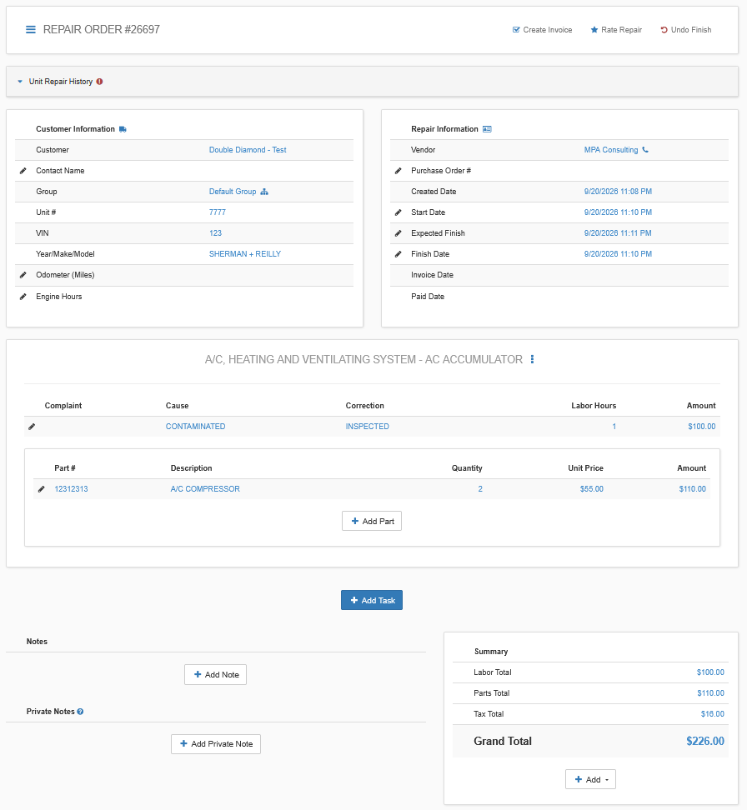
Once the Repair Order is invoiced, it will be automatically imported into Business Central as a Sales Invoice, and posted, with the Unit of the Repair Order being set as the Tractor Code dimension of the Sale Invoice and Posted Sales Invoice:
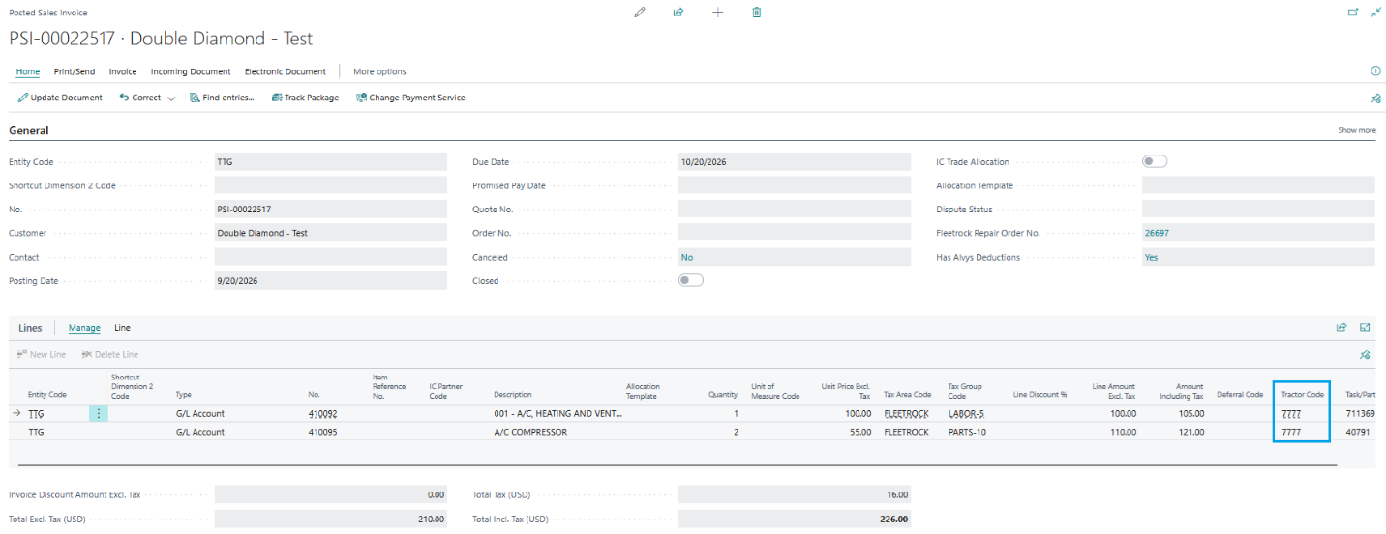
Once the Sales Invoice is posted, a Deduction is created in Alvys for the Truck matching the Tractor Code dimension of the Sales Invoice:
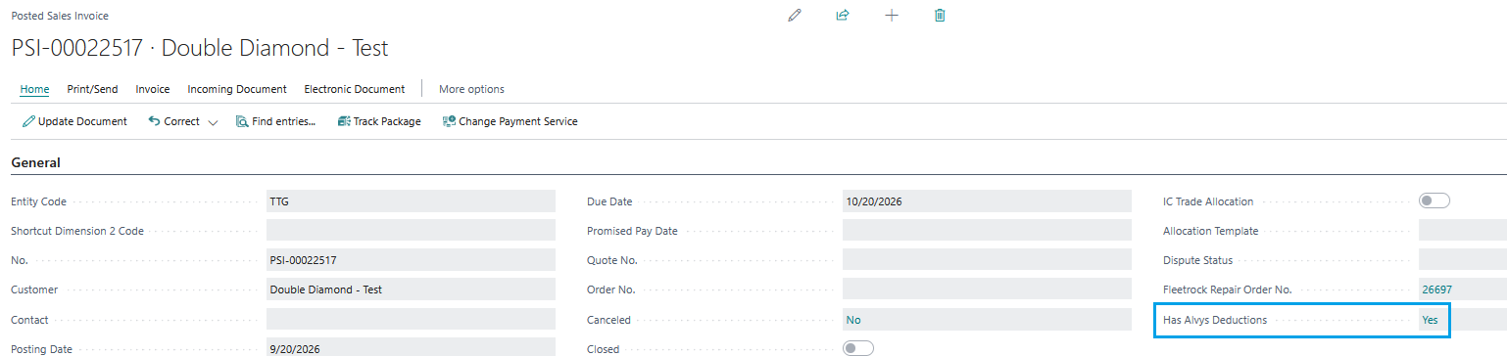
The Description of the Deduction in Alvys will contain the MEM Entity Code, the Business Central Posted Sales Invoice No. and the Fleetrock Repair Order No.:
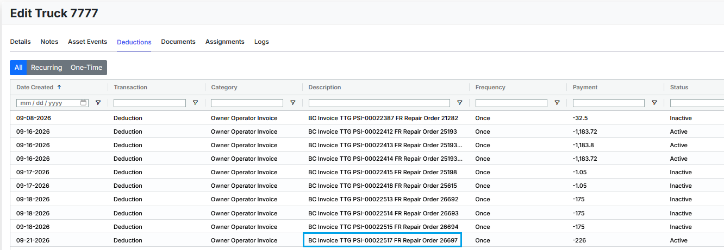

Once the Deduction is marked as Paid in Alvys, a journal line is created and posted automatically in the Import Journal specified on the Alvys Sales Setup page.
Before being posted, the journal line will be applied to the Posted Sales Invoice, and be assigned the Tractor Code dimension that matches the Truck in Alvys:
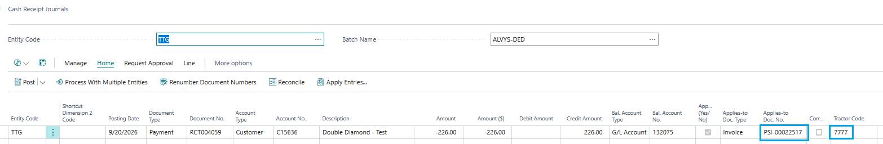
Once the Import Journal has been posted, the Repair Order in Fleetrock is marked as Paid:
